The Newsletter of the Connecticut Building Officials Association

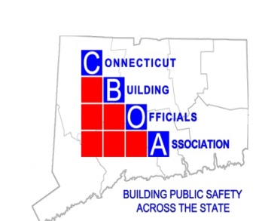
Randy Heckman, President
Joseph Cassidy, Vice-President
Rich McKinnon, Second Vice President
Rich McKinnon, Treasurer
Lou Coppola, Secretary

Mission of the Connecticut Building Officials Association
President's Message
Welcome to a new year of building code bliss. I hope everyone had a great summer. I want to thank the joint efforts of Anthony Cinicola, Lou Fappiano and Rich McKinnon for facilitating the ability to pay for all our meetings and registration online by credit or debit. Our program this month is on Meter Socket Adapters, With Patrick Fam Eversource supervisor meter engineering. If anyone has any subjects for future meetings, please give me a quick email and I will search for presenters.
Meeting registration is required, Register online http://www.ctbuildingofficial.org/Register

Please note mail checks to: Rich McKinnon
222 Bolton Ctr. Rd.
Bolton CT. 06043
Make Checks payable to “CBOA”

If you have not received your ID card yet, please see Tony Cinicola he will have your card. If you have not yet provided your information to receive a card, please provide the following information which should be sent to cboa.ct@outlook.com

Thank you,
Randy Heckman

The mission of the Connecticut Building Officials Association (CBOA) is to promote the Building Code Profession as integral to building safety and advance the understanding, formulation, and enforcement of the Connecticut State Building Code.
Message from Office of State Building Inspector
Dear CBOA Members,

The development of the 2026 Connecticut State Building and Fire Codes is entering its final stages. Throughout the code revision process, the Office of the State Building Inspector (OSBI) and Office of the State Fire Marshal (OSFM) received over 90 Code Change Proposals. Progress on the draft faced significant delays, primarily due to the unusually late release of the 2024 International Energy Conservation Code, which was not published until August 2024.

On May 14, 2025, the Codes and Standards Committee approved the draft amendments, the documents have been reviewed by the Department of Administrative Services’ legal team and are now in preparation for release for Public Comment anticipated to start the last week of August. During this period, stakeholders and members of the public will have the opportunity to review the proposed changes and provide input. Public hearings are anticipated to be held in September 2025.

Among the most notable changes in the 2026 codes are new provisions for fire protection of lithium-ion and lithium-metal batteries; and two new appendices: one permitting single-stair residential buildings up to five stories, and another providing performance criteria for three- and four-family dwellings similar to those found in the International Residential Code. These appendices are being introduced in response to Public Act 24-151, which aims to support increased housing options in light of the statewide housing shortage. The single-stair provision follows a national movement seen in jurisdictions like Seattle, New York City, and Honolulu.

However, the adoption of these provisions will not be statewide. Municipalities must demonstrate adequate firefighting capabilities and submit certification to the Office of the State Fire Marshal before implementing these design options.

Following the public comment period and resolution of any submitted feedback, the code package will be submitted for legislative review, which includes a 45-day review period anticipated in the winter. Final adoption of the 2026 Connecticut State Building and Fire Codes is projected for mid-2026.

To stay informed on the status of the 2026 code adoption process, including upcoming public hearings and release of draft documents, you can sign up for the Code Adoption Listserv by emailing das.codesstandards@ct.gov.

OEDM Training Updates

The Office of Education and Data Management (OEDM) will be re-running PLTP courses for select programs this fall, with a full schedule of 2026 PLTP programs expected by November. In addition, OEDM has a robust lineup of Career Development offerings planned through the end of the year. These will include a mix of in-person and online events, offered in both short and extended formats to meet a variety of professional development needs.

Please check the course registration roster from time to time for the most up to date array of scheduled events. Finally, and as always, OEDM is looking for qualified instructors and trainers looking to teach for their various programs. If you are interested, please contact OEDM at OEDM@ct.gov for more information.

I hope your summers were well-spent and I look forward to seeing you all.

Best regards,
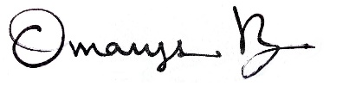
Omarys C. Vasquez, AIA, NOMA | State Building Inspector

Office of the State Building Inspector
Department of Administrative Services
Omarys.vasquez@ct.gov

Thursday March 21, 2024
Manor Inn Restaurant Plantsville CT 1-860-628-9877
8:00 AM to 8:30 Registration Meeting 8:30 – 11:30am

Upcoming: CBOA Calendar 2025-26

Date Activity

September 18 Eversource Meter socket adapters

October 16 TBA

November 20 TBA

December 18 Holliday Meeting

January 15 TBA

February 19 TBA

March 19 TBA

April 16 TBA

May 21 TBA

June 18 Picnic and Installation of Officers

