The Newsletter of the Connecticut Building Officials Association

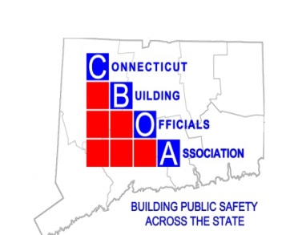
Randy Heckman, President
Joseph Cassidy, Vice-President
Rich McKinnon, Second Vice President
Rich McKinnon, Treasurer
Lou Coppola, Secretary

Mission of the Connecticut Building Officials Association
President's Message
Hope everyone’s snowy March is going well
We will be holding our ICC Benefit Day on March 11th this year at
Connecticut Basement Systems
33 Progress Ave, Building 3
Seymour CT 06483
Significant changes to the IPC, IMC and pool and spa code from 2021 to 2024 code year. Presenter: Gary Gauthier
6 Continuing Education Credits Awarded
Continental Breakfast and Buffet lunch served
$75 members and $125 for non-members checks made out to: CBOA
C/o Rich McKinnon 222 Bolton Center Rd
Bolton, CT 06043
Registration is required to attend and limited to 140p. please visit: https://ctbuildingofficial.org/Register

Thank you,
Randy Heckman

The mission of the Connecticut Building Officials Association (CBOA) is to promote the Building Code Profession as integral to building safety and advance the understanding, formulation, and enforcement of the Connecticut State Building Code.
Dear Colleagues,

I hope this message finds you well. I am writing to provide several timely updates of interest to local building officials, including the status of the next Connecticut State Building Code adoption, training and licensure trends, and a summary of relevant legislation under consideration during the current legislative session.

The next Connecticut State Building Code adoption remains scheduled to take effect on July 1, 2026, with enforcement to follow in accordance with statutory timelines. The regulations have been submitted to the Legislative Regulations Review Committee, and we are currently awaiting resubmission and final approval, which is anticipated in the near future. We appreciate the continued patience of the code enforcement community as this process moves toward completion and will share further updates as soon as they are available.

Since the transition to the new modular training and examination process, we have observed a notable increase in both licensure attainment and examination participation and success rates among candidates. Applications and approvals for building officials are up 14.5% and 22.5%, respectively, and the examination rate from the previous program is up 35% to an impressive 71% pass rate.

Furthermore, as a reminder, the current session of the Connecticut General Assembly is a short legislative session. Nevertheless, several bills under consideration may be of interest to building officials for awareness and future impact:
- SB 255 – An Act Concerning the Certification of Independent Inspectors and Inspection Firms
This bill proposes a framework for certifying independent inspectors and inspection firms to perform State Building Code inspections.
- SB 277 – An Act Implementing State Building Code Provisions Related to Accessibility
The intent of this bill is to allow accessibility waiver requests to be submitted to local building officials first for review and comment prior to submission to the state—consistent with the process used for other code modifications. This approach would improve coordination, streamline review, and ensure local awareness of approved accessibility modifications.
- HB 5261 – An Act Permitting Municipalities to Prohibit Rent Increases in the Event of Multiple State Building Code Violations.
This bill allows municipalities to prohibit rent increases on residential properties with multiple outstanding State Building Code violations.
- HB 5288 – An Act Concerning Utility Connections for Accessory Apartments
This bill prohibits towns, special districts, and utility companies from requiring separate utility service connections for accessory dwelling units under special act zoning rules.
- HB 5339 – An Act Concerning the Permitting of Solar Photovoltaic Systems
This proposal would impact municipalities by establishing fast-track permitting requirements for certain solar photovoltaic installations.
- HB 5340 – An Act Concerning Renewable Power Generation
This bill addresses portable renewable energy generation and does not include provisions related to building permit requirements in this draft and is included for general awareness.
- HB 5376 – An Act Concerning Real Estate
Section 2 of this bill clarifies that projects proceeding under CGS 8-30g must comply with the State Building Code and Fire Code, including documentation demonstrating compliance for projects that utilize nonstandard, prefabricated or proprietary assemblies.
- HB 5401 – An Act Concerning the Procedure for Adopting, Revising, and Amending the State Building Code and Required Related Training
This bill includes provisions related to the building code adoption process, including a potential transition to a six-year code cycle.

Thank you for your continued service and engagement in the administration and enforcement of the State Building Code. Your role is critical to public safety and the effective implementation of these policies. Please feel free to share feedback or questions as these initiatives continue to develop.

Best regards,
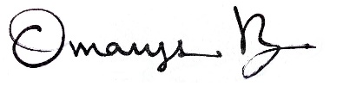
Omarys C. Vasquez, AIA, NOMA | State Building Inspector

Office of the State Building Inspector
Department of Administrative Services
Omarys.vasquez@ct.gov

Upcoming: CBOA Calendar 2025-26

Date Activity

September 18 Eversource Meter socket adapters

October 16 Jim Quish Accessibility Scoping -IBC IRC, & IEBC

November 20 3M 2024_FB_03 Fire Protection for Construction Joints

December 18 Holliday Meeting

January 15 Scott Miller Eversource Battery backup systems

February 19 Denlar Fire Protection Fully Integrated Fire
Protection Hoods
March 11 ICC Benefit Day Gary Gauthier

April 16 Simpson Strong tie

May 21 TBA

June 18 Picnic and Installation of Officers

