The Newsletter of the Connecticut Building Officials Association

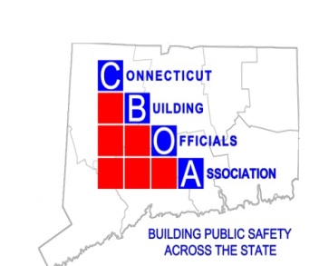
Randy Heckman, President
Joseph Cassidy, Vice-President
Rich McKinnon, Second Vice President
Rich McKinnon, Treasurer
Lou Coppola, Secretary

promote the Building Code Profession as integral to building safety and advance the understanding, formulation, and enforcement of the Connecticut State Building Code.
President's Message
Happy New Year hope everyone had a safe and enjoyable New Year
Thank you all for your food donations from the town of Marlborough
This month’s class is with Eversource doing a presentation from
Scott Miller Eversource Battery backup systems

Register online http://www.ctbuildingofficial.org/Register
Make Checks to CBOA
Please note mail checks to Rich McKinnon
222 Bolton Ctr. Rd.
Bolton CT. 06043
If you have not received your ID card yet, please see Tony Cinicola he will have your card. If you have not yet provided your information to receive a card, please provide the following information which should be sent to cboa.ct@outlook.com
1. Full Name:
2. LMS Number (if applicable):
3. Photo:

Thank you,
Randy Heckman

Thursday March 21, 2024
Manor Inn Restaurant Plantsville CT 1-860-628-9877
8:00 AM to 8:30 Registration Meeting 8:30 – 11:30am

Upcoming: CBOA Calendar 2025-26

Date Activity

September 18 Eversource Meter socket adapters

October 16 Jim Quish Accessibility Scoping -IBC IRC, & IEBC

November 20 3M 2024_FB_03 Fire Protection for Construction Joints

December 18 Holliday Meeting

January 15 Scott Miller Eversource Battery backup systems

February 19 Denlar Fire Protection Fully Integrated Fire
Protection Hoods
March 19 ICC Benefit Day

April 16 Simpson Strong tie

May 21 TBA

June 18 Picnic and Installation of Officers

