The Newsletter of the Connecticut Building Officials Association

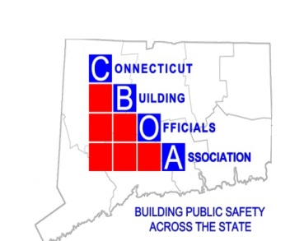
Randy Heckman, President
Joseph Cassidy, Vice-President
Rich McKinnon, Second Vice President
Rich McKinnon, Treasurer
Lou Coppola, Secretary

Mission of the Connecticut Building Officials Association
President's Message
Happy Spring Looks Like It’s Finaly Here
Our guest speaker this month is John Morse from Simpson Strong Tie
- April 16, 2026, Manor Inn 1636 Meriden Waterbury Tpk. Plantsville, CT

- New C-C-2026 Simpson Connector Catalog
- Know how to locate critical information on the proper use and installation of wood connector products
- Know how to identify proper quantities and sizes of fasteners to be used in wood connector application
- Know how to identify proper installation of new Simpson Wood Connector products
- Know how to identify proper anti corrosive coatings on Simpson Wood Connector products
- Know how to identify which fastener holes pertain to various wood connector installations

Congratulations to UCONN both making the final 4
Please see schedule for dates and times below for upcoming ICC Code hearings below Please try to support and have a good showing

Thank you,
Randy Heckman

The mission of the Connecticut Building Officials Association (CBOA) is to promote the Building Code Profession as integral to building safety and advance the understanding, formulation, and enforcement of the Connecticut State Building Code.
State update

Dear Colleagues,

I hope this message finds you well. I am writing to provide several timely updates of interest to local building officials.

The next Connecticut State Building Code adoption remains scheduled to take effect on July 1, 2026, with enforcement to follow in accordance with statutory timelines. The regulations have been submitted to the Legislative Regulations Review Committee, and we expect it will be on their April agenda. We appreciate the continued patience of the code enforcement community as this process moves toward completion and will share further updates as soon as they are available.

Furthermore, as a reminder, the current session of the Connecticut General Assembly is a short legislative session. Nevertheless, several bills under consideration may be of interest to building officials for awareness and future impact:
- SB 255 – An Act Concerning the Certification of Independent Inspectors and Inspection Firms. This bill proposes a framework for certifying independent inspectors and inspection firms to perform State Building Code inspections. Bill is presumed to be dead.
- SB 274 - An Act Concerning Nonresident Landlord Registration and Increasing Penalties for Repeat Building and Fire Code Violations. To require certain nonresident landlords, project-based housing providers or agents in charge of rental properties to register certain personal identifying information and increase penalties for repeat violations of building and fire codes.
- SB 277 – An Act Implementing State Building Code Provisions Related to Accessibility
The intent of this bill is to allow accessibility waiver requests to be submitted to local building officials first for review and comment prior to submission to the state—consistent with the process used for other code modifications. This approach would improve coordination, streamline review, and ensure local awareness of approved accessibility modifications.

Because some folks like a silver platter….Here are the days and books or parts thereof if you need to tailor your attendance….FS= Fire Safety, G is General, S is structural, MP you can guess, B is building

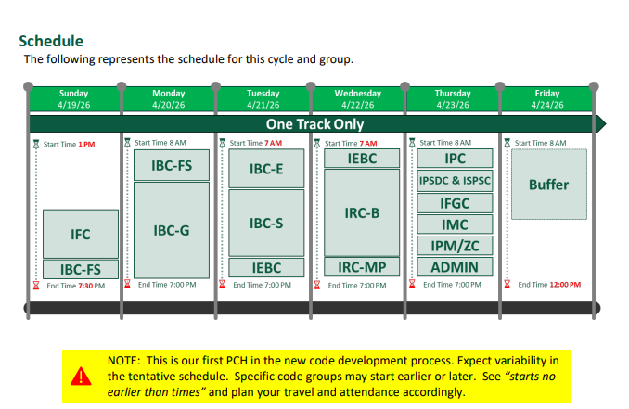Upcoming: CBOA Calendar 2025-26

Date Activity

September 18 Eversource Meter socket adapters

October 16 Jim Quish Accessibility Scoping -IBC IRC, & IEBC

November 20 3M 2024_FB_03 Fire Protection for Construction Joints

December 18 Holliday Meeting

January 15 Scott Miller Eversource Battery backup systems

February 19 Denlar Fire Protection Fully Integrated Fire
Protection Hoods
March 11 ICC Benefit Day Gary Gauthier

April 16 Simpson Strong tie

May 21 Joint meeting On legal Matters with multi family homes

June 18 Picnic and Installation of Officers

